Electrical and Computer Engineering Department

University of Puerto Rico at Mayagüez

Mayagüez, Puerto Rico

**Bandwidth and Capacity of Wireless Communication Systems**

José A Velázquez Torres

802-14-8632

CIIC4070/ICOM5025

Kejie Lu

Computer Engineering

**Table of Content**

1. Introduction 3
2. The Basic 3
3. The regulations 3
4. Standards 4
5. Starlink system 7
6. Conclusion 10
7. References 11

**Introduction**

In this document there will be discussing some of the basics, standards and regulations about bandwidth and capacity of wireless communication systems. In addition to some information of the Starlink system by the company Space X. After reading this report you will have a better understanding of the importance of this standards and regulation, also some of the application of this concepts.

**The basics**

1. The three components to define the bandwidth of a given signal.
   1. The power spectral density
   2. Power Spectrum
   3. The threshold
2. The three components to define the bandwidth of a given wireless channel.
   1. Power spectrum density
   2. Power spectrum
   3. Threshold
3. The Shannon capacity of a wireless channel.
   1. R= Blog2(1+SNR) bps

**The regulations**

1. What is the maximal transmission power fed into the antenna?
   1. The maximum power fed is 30 dBm.
2. What is the meaning of EIRP?
   1. EIRP stands for Effective Isotropic Radiated Power.
3. What is dBi?
   1. The dBi is the antenna gain.
4. What kind of antenna can achieve 30dBi?
   1. The directional antennas can achieve this gain.
5. Wow much it cost?
   1. Price vary depending on the function of the antenna, for common applications I find the prize goes up to $300.

**The standards**

1. How IEEE specifies the requirements for power spectral density for a 20 MHz channel in Chapter 17?
   1. The maximal transmission power depends on the regulatory bodies according to the section 17.3.9.2.
2. Why some people claim that the same channel has a bandwidth of 18MHz?
   1. As stated on Figure 17-13 that is found in section 17.3.9.3 a 18MHz bandwidth is defined when the threshold is set to 0dBr.
3. Why some people claim that the same channel has a bandwidth of 22 MHz?
   1. For a 22MHz bandwidth is set with a threshold is -20dBr as says in Section 17.3.9.3 Figure 17-13.
4. Table (standard/s, spectrum band, bandwidth, maximal transmission power, typical transmission distance and maximal data rate)

|  |  |
| --- | --- |
| Topic | Information |
| Standards | 1. IEEE 802.11a    1. This standard sets the frequency that Wi-Fi works. 2. IEEE 802.11b 3. This standard use more typical frequency and speed. 4. IEEE 802.11g    1. Stands the maximum data rate and usage reliability. 5. IEEE 802.11n    1. Supporting of multi-channel usage. 6. IEEE 802.11ac    1. Increase the data throughput for Wi-fi devices. 7. IEEE 802.11ax    1. Improvements in the ac standard. |
| Spectrum Band | 1. Extremely low frequency (ELF) 2. Super low frequency (SLF) 3. Ultra low frequency (ULF) 4. Very low frequency (VLF) 5. Low frequency (LF) 6. Medium frequency (MF) 7. High frequency (HF) 8. Very high frequency (VHF) 9. Ultra high frequency (UHF) 10. Super high frequency (SHF) 11. Extremely high frequency (EHF) 12. Tremendously high frequency (THF) |
| Bandwidth | 1. 20 MHz 2. 40 MHz 3. 60 MHz 4. 80 MHz 5. 160 MHz |
| Maximal transmission power | Currently is 20dBm |
| Transmission Distance | 1. Bluetooth: 10 meters 2. Wi-fi: several hundred meters 3. EnOcean: 200m 4. Broadban: 1km 5. Narrow Band: 1km |

|  |  |
| --- | --- |
| Bandwidth | Data rate |
| 20-160MHz with 2.4-5GHz freq | 2.4Gbps |
| 20-160MHz with 5 GHz freq | 1.73Gbps |
| 20-80MHz with 5GHz freq | 886.7 Mbps |
| 20-40MHz with 2.4-5GHz freq | 450 Mbps |
| 20 MHz with 2.4 GHz freq | 54 Mbps |
| 20MHz with 5GHz freq | 54 Mbps |
| 20MHz with 2.4GHz freq | 11 Mbps |
| 20MHz with 2.4GHz freq | 2 Mbps |

|  |  |
| --- | --- |
| Technology | Standard |
| Near Field Communication (NFC) | ISO/IEC 1800-3 |
| Bluetooth version 5.0 | IEEE 802.15.1 |
| Zigbee | IEEE 802.15.4 |
| Wi-fi 5 | IEEE 802.11ac |
| Wi-Gig | IEEE 802.11ad |

**The Starlink system**

1. What are the main altitudes of orbits used in the Starlink satellite system?
   1. The altitude for the Starlink satellite system is 550km.
2. What are the frequency bands for each of the above orbits?
   1. The frequency bands are:
      1. 10.7–12.7 GHz
      2. 14–14.5 GHz
      3. 17.8–18.55 GHz
      4. 18.8–19.3 GHz
      5. 27.5–29.1 GHz
      6. 29.5–30 GHz
   2. Word doc (consultation paper)
3. What are the bandwidths for each of the bands above?
   1. The bandwidths will be:
      1. 12-18GHz for Ku
      2. 26.5-40GHz for Ka
      3. 40-75GHz for V
4. What is the range of received power at an existing user terminal?
   1. According to a beta tester of the system power for a user terminal to work is around 116w.
5. What is the maximal uplink data rate observed at an existing user terminal?
   1. The maximal uplink for tracking, telemetry and control is 14 GHz and 47.45 GHz.
      1. Elonx.net
6. What is the maximal downlink data rate observed at an existing user terminal?
   1. The maximal downlink for tracking, telemetry and control is 12.25 GHz and 18.60 GHz.
   2. Elonx.net
7. What is the minimal uplink latency observed at an existing user terminal?
   1. The latency exhibit in the user terminals goes between 18-19 milliseconds.
8. What is the minimal downlink latency observed at an existing user terminal?
   1. The minimal downlink latency goes down to 18 milliseconds.
9. Visit <https://satellitemap.space/indexA.html> and
   1. take a screen shot when Puerto Rico is covered by a Starlink satellite. 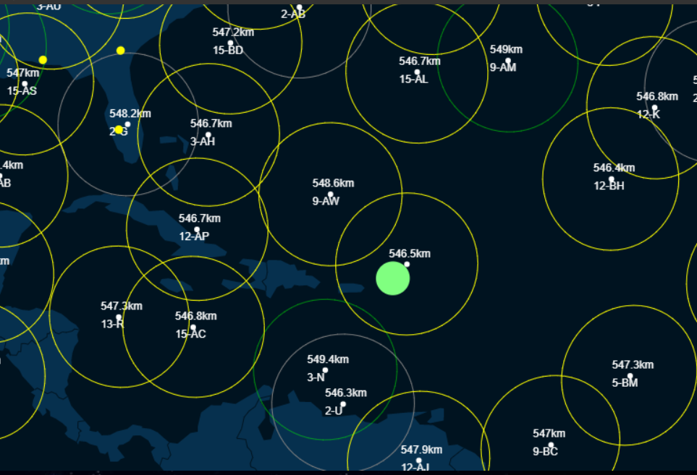
   2. take a screen shot of the chain of all satellites with ID: 17-xx



* 1. take a screen shot of the chain of all satellites with ID: 18-xx

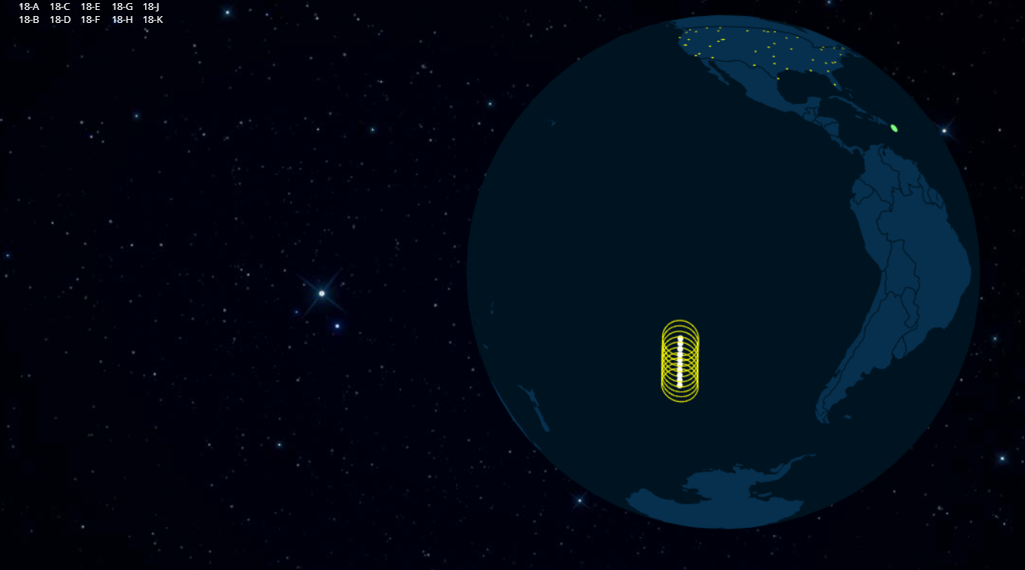

**Conclusion**

Once completed this report I had a better understanding of the importance of the bandwidth and capacity on wireless communication. These aspects have a big impact on the application of this type of communication and is amazing how it keeps improving over the time becoming faster and capable of handling bigger chunks of information. We can also see the implication of this in the ambitious project of the company Space X, Starlink, where they abuse some aspects of wireless communication to have a better performance. Is incredible what we can achieve if we keep pushing the limits of the technology we have.

**References**

[1]"Shannon Capacity - an overview | ScienceDirect Topics", *Sciencedirect.com*, 2021. [Online]. Available: https://www.sciencedirect.com/topics/computer-science/shannon-capacity. [Accessed: 20- Feb- 2021].

[2]"Antenna Basics", *SimpleWiFi*, 2021. [Online]. Available: https://www.simplewifi.com/pages/antenna-basics. [Accessed: 20- Feb- 2021].

[3]"The Most Common Wi-Fi Standards and Types, Explained", *MUO*, 2021. [Online]. Available: https://www.makeuseof.com/tag/understanding-common-wifi-standards-technology-explained/#:~:text=Wireless%20standards%20are%20a%20set,Fi%20standard%20every%20few%20years. [Accessed: 21- Feb- 2021].

[4]"Radio spectrum", *En.wikipedia.org*, 2021. [Online]. Available: https://en.wikipedia.org/wiki/Radio_spectrum. [Accessed: 20- Feb- 2021].

[5]"Maximum Transmit Power - an overview | ScienceDirect Topics", *Sciencedirect.com*, 2021. [Online]. Available: https://www.sciencedirect.com/topics/engineering/maximum-transmit-power. [Accessed: 20- Feb- 2021].

[6]"Wireless Communication ＜Short-Range Wireless Communication＞ | Electronics Basics | ROHM", *Rohm.com*, 2021. [Online]. Available: https://www.rohm.com/electronics-basics/wireless/short-range-wireless-communication. [Accessed: 21- Feb- 2021].

[7]"Different Wi-Fi Protocols and Data Rates", *Intel*, 2021. [Online]. Available: https://www.intel.com/content/www/us/en/support/articles/000005725/wireless.html. [Accessed: 20- Feb- 2021].

[8]"Near Field Communication Technology Standards – NearFieldCommunication.org", *Nearfieldcommunication.org*, 2021. [Online]. Available: http://nearfieldcommunication.org/technology.html. [Accessed: 20- Feb- 2021].

[9]"IEEE 802.15.1", *Ieee802.org*, 2021. [Online]. Available: https://www.ieee802.org/15/pub/TG1.html. [Accessed: 21- Feb- 2021].

[10]"Home - Zigbee Alliance", *Zigbee Alliance*, 2021. [Online]. Available: https://zigbeealliance.org/. [Accessed: 21- Feb- 2021].

[11]"Wi-Fi CERTIFIED ac | Wi-Fi Alliance", *Wi-fi.org*, 2021. [Online]. Available: https://www.wi-fi.org/discover-wi-fi/wi-fi-certified-ac. [Accessed: 21- Feb- 2021].

[12]e. notes, "WiGig IEEE 802.11ad | 60 GHz Microwave Wi-Fi | Electronics Notes", *Electronics-notes.com*, 2021. [Online]. Available: https://www.electronics-notes.com/articles/connectivity/wifi-ieee-802-11/802-11ad-wigig-gigabit-microwave.php. [Accessed: 21- Feb- 2021].

[13]"Starlink's satellites will be orbiting at a much lower altitude, reducing the risks of space junk", *Phys.org*, 2021. [Online]. Available: https://phys.org/news/2019-05-starlink-satellites-orbiting-altitude-space.html. [Accessed: 21- Feb- 2021].

[14]"Starlink Compendium – ElonX.net", *ElonX.net*, 2021. [Online]. Available: https://www.elonx.net/starlink-compendium/#constellation. [Accessed: 21- Feb- 2021].

[15]J. Brodkin, "SpaceX Starlink users provide first impressions and unboxing pictures", *Ars Technica*, 2021. [Online]. Available: https://arstechnica.com/information-technology/2020/11/spacex-starlink-beta-tester-takes-user-terminal-into-forest-gets-120mbps/. [Accessed: 21- Feb- 2021].

[16]S. Vaughan-Nichols, "The Starlink internet beta has begun: Here's what to expect | ZDNet", *ZDNet*, 2021. [Online]. Available: https://www.zdnet.com/article/the-starlink-internet-beta-has-begun-heres-what-to-expect/#:~:text=In%20this%20early%20stage%2C%20Starlink,we%20enhance%20the%20Starlink%20system. [Accessed: 21- Feb- 2021].

[17]J. Koetsier, "Starlink Internet From Space: Faster Than 95% Of USA", *Forbes*, 2021. [Online]. Available: https://www.forbes.com/sites/johnkoetsier/2020/11/01/starlink-internet-from-space-faster-than-95-of-usa/?sh=3e874e301bb0. [Accessed: 21- Feb- 2021].

[18]"Starlink satellite tracker", *Starlink satellite tracker*, 2021. [Online]. Available: https://satellitemap.space/indexA.html. [Accessed: 21- Feb- 2021].

[19]*IEEE Standard for Information technology Telecommunications and information exchange between systems Local and metropolian area networks Specific requirements Part 11: Wireless LAN Medium Access Control (MAC) and Physical Layer (PHY) Specifications*. New York: IEEE Computer Society, 2016.

[20]"5 GHz airMAX 30 dBi RocketDish Antenna", *Ubiquiti Inc.*, 2021. [Online]. Available: https://store.ui.com/collections/operator-airmax-and-ltu/products/5ghz-rocketdish-30dbi-rocket-kit. [Accessed: 20- Feb- 2021].

[21]M. included), "MikroTik mANT30 Antenna 4.7-5Ghz 30dBi Dual-Pol 45deg Slant Dish with Precision Alignment Mount (RP-SMA patch cables included)", *Baltic Networks*, 2021. [Online]. Available: https://www.balticnetworks.com/mikrotik-mant30-antenna-4-7-5ghz-30dbi-dual-pol-45deg-slant-dish-with-precision-alignment-mount-rp-sma-patch-cables-included. [Accessed: 20- Feb- 2021].